➢ Problems for Making Equivalent SQL Queries

Given the following queries, transform each query into another equivalent query (i.e., providing the same results) while satisfying the stated requirements.

(Note: the transformed query should not be worked by two steps. That is, it is not allowed to use the results of executing the nested query in the original query.)

➢ Submission

Read carefully this guidance for submission.

Submission components for given each query: 1) transformed query, 2) actual results executing an original query on Oracle databases(captured image), 3) actual results executing the transformed query on Oracle databases(captured image), and 4) the explanations why the transformed query is equivalent to the original query.

When you capture the screen to show actual results, you MUST contain a cmd window to show your unique IP address (type ipconfig in cmd windows) as follows. This means you show two windows in a screen where one is SQL Plus to show the results and the other is cmd windows to show your IP address of PC you were working.



Make one file named “HW#1_STUDENTID.doc” (ppt, or pdf) including all the things as stated above and submit the file into e-class system.

1. Transform the following nested query into unnested query

|  |
| --- |
| SELECT pack_id, speed , sector_id  FROM acdb_packages  WHERE sector_id =  (SELECT sector_id FROM acdb_packages WHERE pack_id = 10); |

* Transformed Query

select A.PACK_ID, A.SPEED, A.SECTOR_ID

from ACDB_PACKAGES a, ACDB_PACKAGES b

where B.PACK_ID = 10 and A.SECTOR_ID = B.SECTOR_ID;

* Result of Original Query

* Result of Transformed Query

* Explanation

Using self-join. Get two relations with different nicknames a and b. Then, we make join with sector_id of a and b. And add a condition b.pack_id = 10.

2. Transform the following nested query into unnested query

|  |
| --- |
| SELECT first_name , last_name , join_date  FROM acdb_customers  WHERE extract(year from join_date) =  (SELECT extract(year from join_date) FROM acdb_customers WHERE customer_id = 372)  AND  extract (month from join_date) =  (SELECT extract (month from join_date) FROM acdb_customers WHERE customer_id = 372); |

* Transformed Query

select a.first_name , a.last_name , a.join_date

from acdb_customers a, acdb_customers b

where extract(year from a.join_date) = extract(year from b.join_date) and b.customer_id = 372

intersect

select a.first_name, a.last_name, a.join_date

from acdb_customers a, acdb_customers b

where extract(month from a.join_date) = extract(month from b.join_date) and b.customer_id = 372;

* Result of Original Query

* Result of Transformed Query

* Explanation

Using self-join and introduce intersect to get common part of both tables. One table is consisted of same people who have birth year which is same with customer_id 372’s birth year. And the other is consisted of same people who have birth month which is same with customer_id 372’s birth month. Using intersect operator, we can filter the results and find out those who are having same birth year and month which is same with customer_id 372.

3. Transform the following nested query into unnested query

|  |
| --- |
| SELECT first_name , last_name , city , state, pack_id  FROM acdb_customers  WHERE pack_id IN (SELECT pack_id FROM acdb_packages WHERE speed = '5Mbps'); |

* Transformed Query

select c.first_name, c.last_name, c.city, c.state, c.pack_id

from acdb_customers c, acdb_packages p

where c.pack_id = p.pack_id and p.speed = '5Mbps';

* Result of Original Query

* Result of Transformed Query

* Explanation

To unnest query, we can make join in main query instead of sub query of IN operator.

Join the two relations with ‘=’. And add condition speed = ‘5Mbps’.

4. Transform the following nested query into unnested query

|  |
| --- |
| SELECT first_name , monthly_discount , pack_id , main_phone_num ,  secondary_phone_num  FROM acdb_customers  WHERE pack_id IN  (SELECT pack_id  FROM acdb_packages  WHERE sector_id IN  (SELECT sector_id  FROM acdb_sectors  WHERE sector_name = 'Business')); |

* Transformed Query

select c.first_name, c.monthly_discount, c.pack_id, c.main_phone_num, c.secondary_phone_num

from acdb_customers c, acdb_packages p, acdb_sectors s

where c.pack_id = p.pack_id and p.sector_id = s.sector_id and s.sector_name = 'Business';

* Result of Original Query

* Result of Transformed Query

* Explanation

Multiple nested query with IN operator with different three relations. Then, we can use multiple joins with three tables by FROM and WHERE clause. Join with the foreign key for each relation and then add the condition for our target.

5. Transform the following nested query into unnested query

|  |
| --- |
| SELECT customer_id , first_name , city , state ,birth_date , monthly_discount  FROM acdb_customers  WHERE birth_date =  (SELECT birth_date FROM acdb_customers WHERE customer_id = 179)  AND  monthly_discount >  (SELECT monthly_discount FROM acdb_customers WHERE customer_id = 107); |

* Transformed Query

select a.customer_id, a.first_name, a.city, a.state, a.birth_date, a.monthly_discount

from acdb_customers a, acdb_customers b, acdb_customers c

where a.birth_date = b.birth_date and b.customer_id = 179

and a.monthly_discount > c.monthly_discount and c.customer_id = 107;

* Result of Original Query

* Result of Transformed Query

* Explanation

Using self-join. Get the same relations with different three alias name.

Change sub query into (a.birth_date = b.birth_date and b.customer_id = 179), and (a.monthly_discount > c.monthly_discount and c.customer_id = 107)

6. Transform the following query into another query so as to use EXISTS or NOT EXISTS operator

|  |
| --- |
| SELECT pack_id, speed, monthly_payment  FROM acdb_packages  WHERE monthly_payment > ALL(SELECT monthly_payment FROM acdb_packages WHERE speed = '5Mbps'); |

* Transformed Query

select a.pack_id, a.speed, a.monthly_payment

from acdb_packages a

where not exists(select a.monthly_payment from acdb_packages b where a.monthly_payment <= b.monthly_payment and b.speed='5Mbps');

* Result of Original Query

* Result of Transformed Query

* Explanation

To get ALL things that satisfy the condition is equal to find and remove ALL things that do not satisfy the condition. So, ‘> ALL’ can be replaced with ‘NOT EXISTS’. In NOT EXISTS’ sub query, conditions should be opposite from the condition of ALL’s sub query.

7. Transform the following query into another query so as to use EXISTS or NOT EXISTS operator

|  |
| --- |
| SELECT pack_id ,speed , monthly_payment  FROM acdb_packages  WHERE monthly_payment > ANY (SELECT monthly_payment FROM acdb_packages WHERE speed = '5Mbps'); |

* Transformed Query

select a.pack_id, a.speed, a.monthly_payment

from acdb_packages a

where exists(select a.monthly_payment from acdb_packages b where b.speed='5Mbps' and a.monthly_payment > b.monthly_payment);

* Result of Original Query

* Result of Transformed Query

* Explanation

The specified query must select a monthly payment greater than the user at 5 Mbps speed. So I used the EXITES operator to transform a given query.

8. Transform the following query into another query so as to use COUNT(*) operator

|  |
| --- |
| SELECT pack_id ,speed , monthly_payment  FROM acdb_packages p1  WHERE EXISTS (select * FROM acdb_packages p2 WHERE p2.speed = '5Mbps'  and p1.monthly_payment <= p2.monthly_payment); |

* Transformed Query

select a.pack_id, a.speed, a.monthly_payment

from acdb_packages a

where (select count(*) from acdb_packages b where b.speed='5Mbps' and a.monthly_payment <= b.monthly_payment)>0;

* Result of Original Query

* Result of Transformed Query

* Explanation

EXISTS means that there is at least one data that meets the criteria. So, I used 'COUNT' aggregation to count the number of data that fit the conditions. It has something, then it should be more than zero.

9. Transform the following query into another query so as to use EXISTS or NOT EXISTS operator

|  |
| --- |
| SELECT pack_id ,speed , monthly_payment  FROM acdb_packages p1  WHERE p1.pack_id IN (select p2.pack_id FROM acdb_packages p2 WHERE p2.speed = '5Mbps' AND p1.monthly_payment <= p2.monthly_payment); |

* Transformed Query

select a.pack_id, a.speed, a.monthly_payment

from acdb_packages a

where exists(select a.pack_id from acdb_packages b where a.pack_id = b.pack_id and b.speed ='5Mbps' and a.monthly_payment <= b.monthly_payment);

* Result of Original Query

* Result of Transformed Query

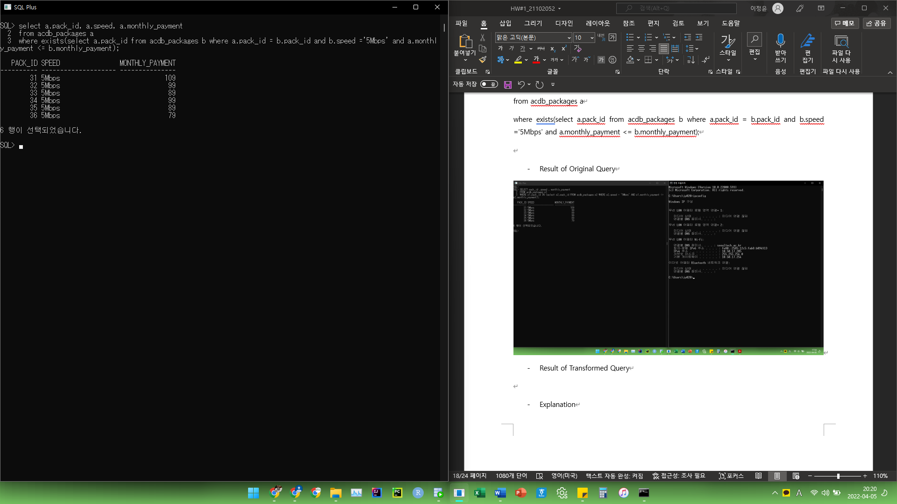

* Explanation

IN operator and EXISTS operator can make same result. In each WHERE clause, the query requires to get pack_id of main query’s acdb_packages. So p1.pack_id or a.pack_id in sub query.

In transformed query, I used join to connect two relations, a and b. And then, add some same conditions from the original sub query in my own sub query’s WHERE clause.

10. Transform the following query into another query so as to use EXISTS or NOT EXISTS operator

|  |
| --- |
| SELECT pack_id ,speed , monthly_payment  FROM acdb_packages p1  WHERE p1.pack_id NOT IN (select p2.pack_id FROM acdb_packages p2 WHERE p2.speed = '5Mbps'  AND p1.monthly_payment <= p2.monthly_payment); |

* Transformed Query

select a.pack_id, a.speed, a.monthly_payment

from acdb_packages a

where not exists(select a.pack_id from acdb_packages b where a.pack_id = b.pack_id and b.speed='5Mbps' and a.monthly_payment <= b.monthly_payment);

* Result of Original Query

* Result of Transformed Query

* Explanation

NOT IN operator and NOT EXISTS operator can make same result. The original query asks to get pack_id which is not fit in the sub query’s condition. Then, we can use NOT EXISTS with sub query which has join operation between a and b. After that, add some conditions from the condition original sub query.

11. Transform the following query into another query so as to use MAX operator without ALL operator

|  |
| --- |
| SELECT pack_id ,speed , monthly_payment  FROM acdb_packages  WHERE monthly_payment  > ALL(SELECT monthly_payment FROM acdb_packages WHERE speed = '5Mbps'); |

* Transformed Query

select a.pack_id, a.speed, a.monthly_payment

from acdb_packages a

where a.monthly_payment > (select max(b.monthly_payment) from acdb_packages b where b.speed='5Mbps');

* Result of Original Query

* Result of Transformed Query

* Explanation

‘Attribute > ALL()’ means that we want to find values in attribute, which are having higher value than other all results of the sub query’s of ALL, i.e., higher than maximum value of sub query. So, we can introduce MAX aggregation in SELECT clause of nested query, then we can get same result of original query.

12. Transform the following query into another query so as to use MIN operator without SOME operator

|  |
| --- |
| SELECT pack_id ,speed , monthly_payment  FROM acdb_packages  WHERE monthly_payment  > ANY(SELECT monthly_payment FROM acdb_packages WHERE speed = '5Mbps'); |

*SOME == ANY

* Transformed Query

select a.pack_id, a.speed, a.monthly_payment

from acdb_packages a

where a.monthly_payment > (select min(b.monthly_payment) from acdb_packages b where b.speed='5Mbps')

* Result of Original Query

* Result of Transformed Query

* Explanation

‘Attribute > ANY()’ means that we want to find values in attribute, which are having higher value than other any results of the sub query’s of ANY, i.e., higher than minimum value of sub query. So, we can introduce MIN aggregation in SELECT clause of nested query, then we can get same result of original query.